Fairfield Surgery - Primary Care Resource Centre, Moor Road, Port
Talbot, West Glamorgan, SA12 7BJ. 01639 500590

Calculate & Submit Your Average Blood Pressure A blood
pressure test is a simple way of checking if your blood pressure is too high or too low.
Blood pressure is the term used to describe the strength with which your blood pushes on the sides of your arteries as it's pumped around your body.
Blood Pressure Chart
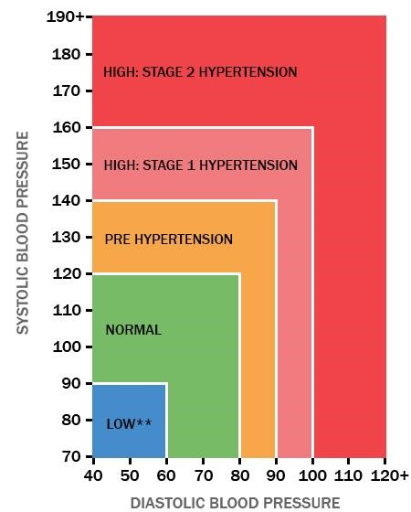

High blood pressure (hypertension) can put a strain on your arteries and organs, which can increase your risk of developing serious problems such as heart attacks and strokes.
Low blood pressure (hypotension) isn't usually as serious, although it can cause dizziness and fainting in some people.
A blood pressure test is the only way to find out if your blood pressure is too high or too low, because most people won't have any obvious symptoms. Having a test is easy and could save your life.

We recommend that you monitor your blood pressure at home. Everyone’s blood pressure naturally rises and falls over the course of a day and some people can be stressed or anxious when having their blood pressure taken by their doctor or nurse, making their blood pressure higher than it normally is (known as ‘white coat effect’). This means that a ‘one-off’ reading taken at your doctor’s surgery may not accurately reflect your real blood pressure.

High blood pressure (hypertension) that is not properly treated is a risk factor for heart disease and strokes. Monitoring your own blood pressure at home should give us more accurate results than checking it at the surgery.

Please take your blood pressure in the morning and the evening for the next
3 / 4 / 5 / 6 / 7 days. Try to take the blood pressure at the same time every day. On each occasion, take two blood pressure readings, on the same arm, 3-5 minutes apart, and record the results on the table overleaf.

Before you take your reading:

• You should not smoke, have a drink containing caffeine (such as coffee) or exercise for 30 minutes before you take your blood pressure reading.

• You should also avoid measuring your blood pressure when you need to use the toilet.

• It is important that you always measure your blood pressure in the same arm.

• You should rest for at least five minutes before measuring your blood pressure

• You should avoid talking whilst taking your blood pressure reading

Full Name
Date of Birth
Phone Number (Mobile Preferred)
Post Code
Day | Time | Systolic | Diastolic  olic
Day 1 | AM 1
Day 1 | AM 2
Day 1 | PM 1
Day 1 | PM 2
Day 2 | AM 1
Day 2 | AM 2
Day 2 | PM 1
Day 2 | PM 2
Day 3 | AM 1
Day 3 | AM 2
Day 3 | PM 1
Day 3 | PM 2
Day 4 | AM 1
Day 4 | AM 2
Day 4 | PM 1
Day 4 | PM 2
Day 5 | AM 1
Day 5 | AM 2
Day 5 | PM 1
Day 5 | PM 2
Day 6 | AM 1
Day 6 | AM 2
Day 6 | PM 1
Day 6 | PM 2
Day 7 | AM 1
Day 7 | AM 2
Day 7 | PM 1
Day 7 | PM 2

